Kyle

Layout
- 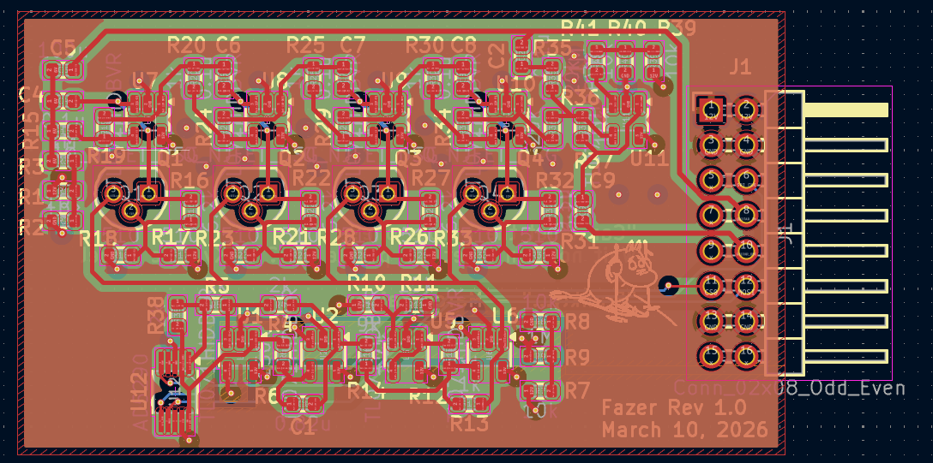This won’t be able to slide into anything bc of how close things are to the edge. We might need to move the oscillator to the far left and shift the phase shifting down more towards the center of the board.
- In general, there are a lot of clearance violations, and not all are due to footprints. I think that some routing could be redone to avoid these (there is definitely space to do so around some of these violations).

